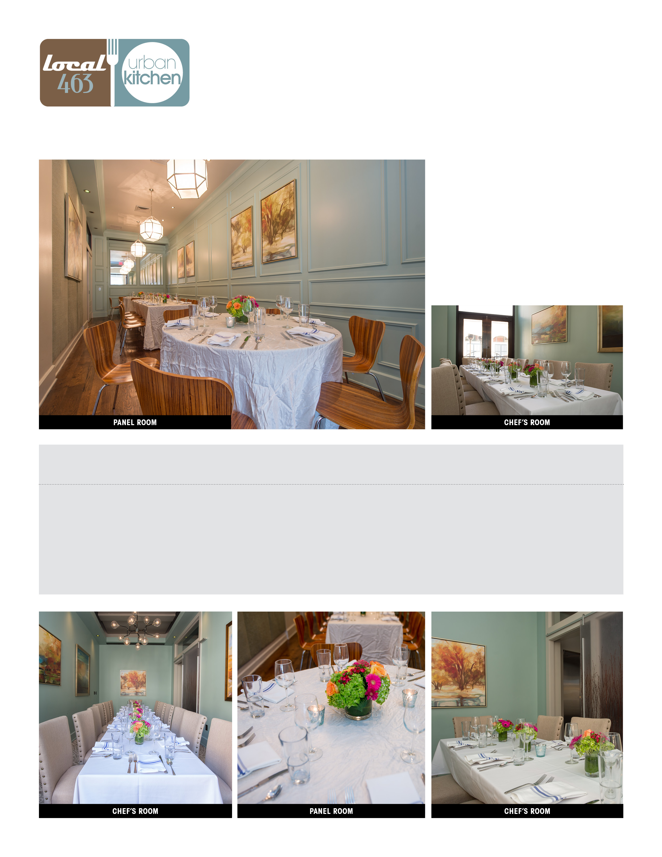

EVENT SPACE CAPACITY FOOD MINIMUM FOOD MINIMUM FOOD MINIMUM

SEATS/COCKTAIL MON-WED NIGHT THU-SAT NIGHT LUNCH

Chef’s Room 18/30 $900 $1200 $400 (MON-SAT)

Panel Room 30/50 $1500 $2000 $1000 (MON-FRI) $600 (SAT)

Sun Room 60/125 $4500 $6000 -

All minimums exclude tax and 20% gratuity

LAUREN RUSHTON

W. 601.707.7684

M. 662.801.1842

LAUREN@LOCAL463.COM

WE ARE the specialists in fine dining for the metro area. we have you covered whether it’s Downtown Jackson, the Historic Fondren District, or Renaissance at Ridgeland. Our team will take care of all the details. Signature dishes from our great restaurants are available in all of our private dining rooms.