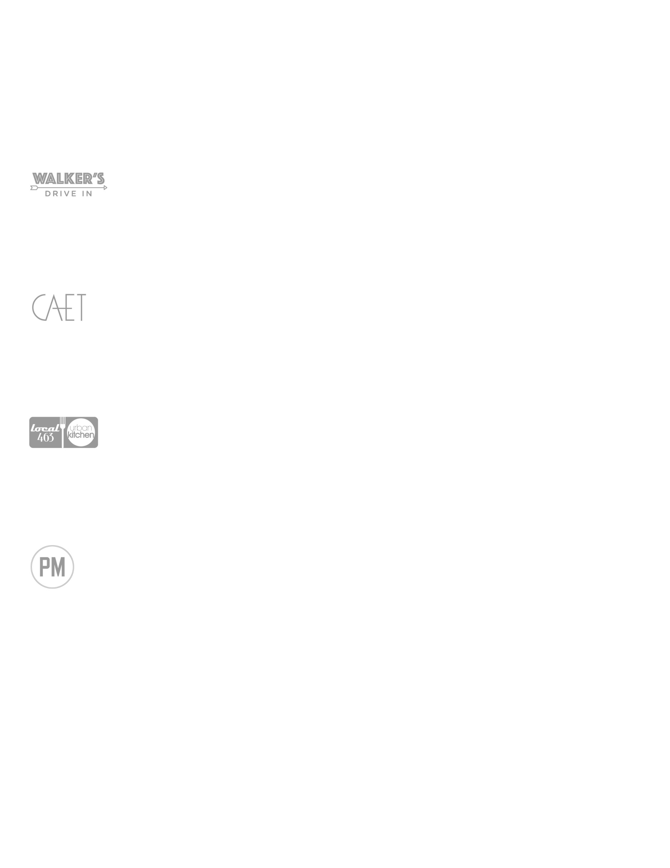

A $500.00 deposit will be charged to the credit card above unless prior arrangements have been made. All reserved dates must be held by a deposit.

CANCELLATION POLICY

• **Cancellations made 30 days** prior to this event will be accepted and this contract will be considered void.

• **Cancellations made 14 days prior** to this event will be accepted; however, the $500.00 deposit will be forfeited.

• **Cancellations given within 14 days** of this event will be accepted with the room minimum enforced, guaranteed and paid by the above credit card holder**.**

FOOD & BEVERAGE MINIMUM POLICY

In the event that the food & beverage minimum is not met, any requests for food/wine to be taken are at the sole discretion of the restaurant. No gift certificates will be issued as part of the minimum under any circumstances.

NAME

COMPANY NAME (if applicable)

DATE OF EVENT

LOCATION OF EVENT EVENT SPACE

NUMBER OF GUESTS ARRIVAL TIME

PHONE

CREDIT CARD EXP CV

SIGNATURE

RENTAL CONTRACT

There is no rental fee; however, there is a food and beverage minimum that must be met in order to reserve a room for a private function. A $500.00 deposit will be required to hold the room. Once a deposit and a contract has been completed, signed and received by the restaurant, the room will be held and considered yours for the entire evening. We recommend set menus for parties of 18 or more. We do not offer multiple checks for larger parties. All minimums exclude tax and 20% gratuity.

Please return your signed and completed contract to the appropriate contact listed at left.

EFFIE HUBANKS

W. 601.982.2633

M. 601.906.3951

EFFIE@WALKERSDRIVEIN.COM

JENNIFER EMERSON

W. 601.321.9169

M. 601.906.4264

JENEMERSON1@GMAIL.COM

ALEX FERGUSON

W. 601.707.7684

M. 601.278.6731

ALEX@LOCAL463.COM

JENNIFER EMERSON

W. 601.360.0090

M. 601.906.4264

JENEMERSON1@GMAIL.COM